Medical Informatics: Comprehensive Project Plan

Ivan Novasak

Southern New Hampshire University

IT 625: Information Technology Project and Team Management

Wendy Lamont

2024 September 29

# Medical Informatics: Comprehensive Project Plan

The purpose of this document is to develop a new plan for Medical Informatics on a product that had fallen behind after the project manager left and has a conflict between some of the team members preventing progress.

# Conflict Resolution Plan

This first section is for analysing the Medical Informatics case study (Lamont, 2024a) team dynamics, recommending a leadership strategy that will resolve the conflict, and generate motivation and confidence for the team to improve their confidence and deliver positive results for the business. The plan was for Medical Informatics to launch a software product in December 2017 that gathers medical data from wellness vendors and clinics and incorporate the data to ‘downstream employer group analytics and reporting processes’ (Lamont, 2024a, p 1).

# Team Dynamics

# *Team Roles and Titles, Reporting Structure, History*

The project’s team consists of the following members referenced in a Microsoft Project file that was attached to the case study document by Wendy Lamont (2024a):

* Business Analyst
* 2 ETL Developers
* 2 Report Developers
* 2 Project Managers
* Architect
* Quality Assurance
* SME (what the initialism stands for was unspecified in (Lamont, 2024a)
* Information Systems Manager
* Business Owner
* All stakeholders
* Database Administrators
* 2 Software Developers
* Technical Support

The project began on 5 May 2017 and was expected to finish on 21 December 2017 when the modular software package being developed was to launch (Lamont, 2024a, p 1). The business case’s compilation and approval, as well as the overall team for this project were established before 5 May 2017 (Lamont, 2024a, p 1). The team consisted entirely of people who worked on other similar projects in different roles at the company, with John, the original project manager, having been with the company for 23 years (Lamont, 2024a, p 3). The exact roles of each team member for this project are shown in the Microsoft Project screenshots in Figures 1–3.

**Figure 1**

*Duration, team member roles, and costs of each task from the Initiation phase to the beginning of the Final Code Review in Module 1.*

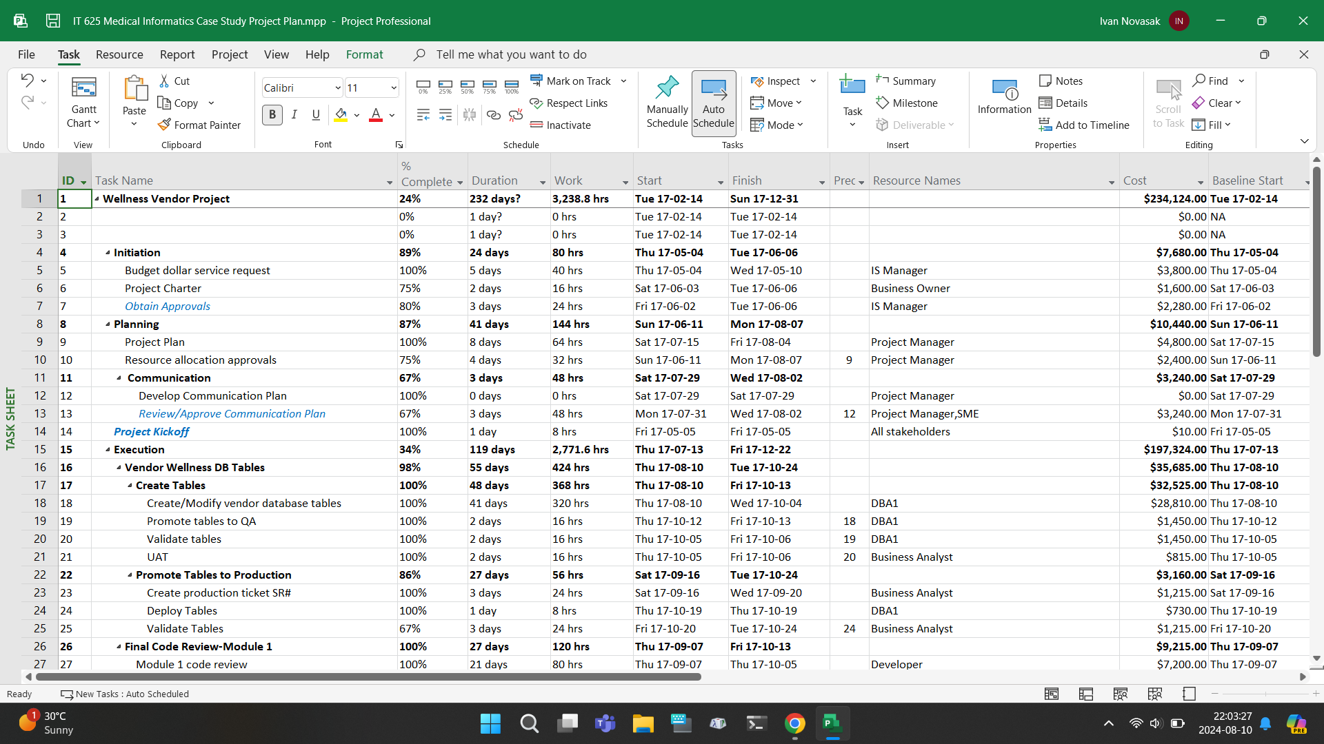

**Figure 2**

*Duration, team member roles, and costs of each task from the Module 1 code review to the middle of the Wellness Vendor Reporting phase.*

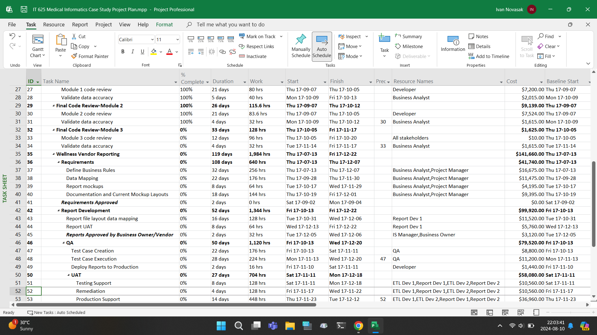

**Figure 3**

*Duration, team member roles, and costs of each task from the QA phase to project’s closing.*

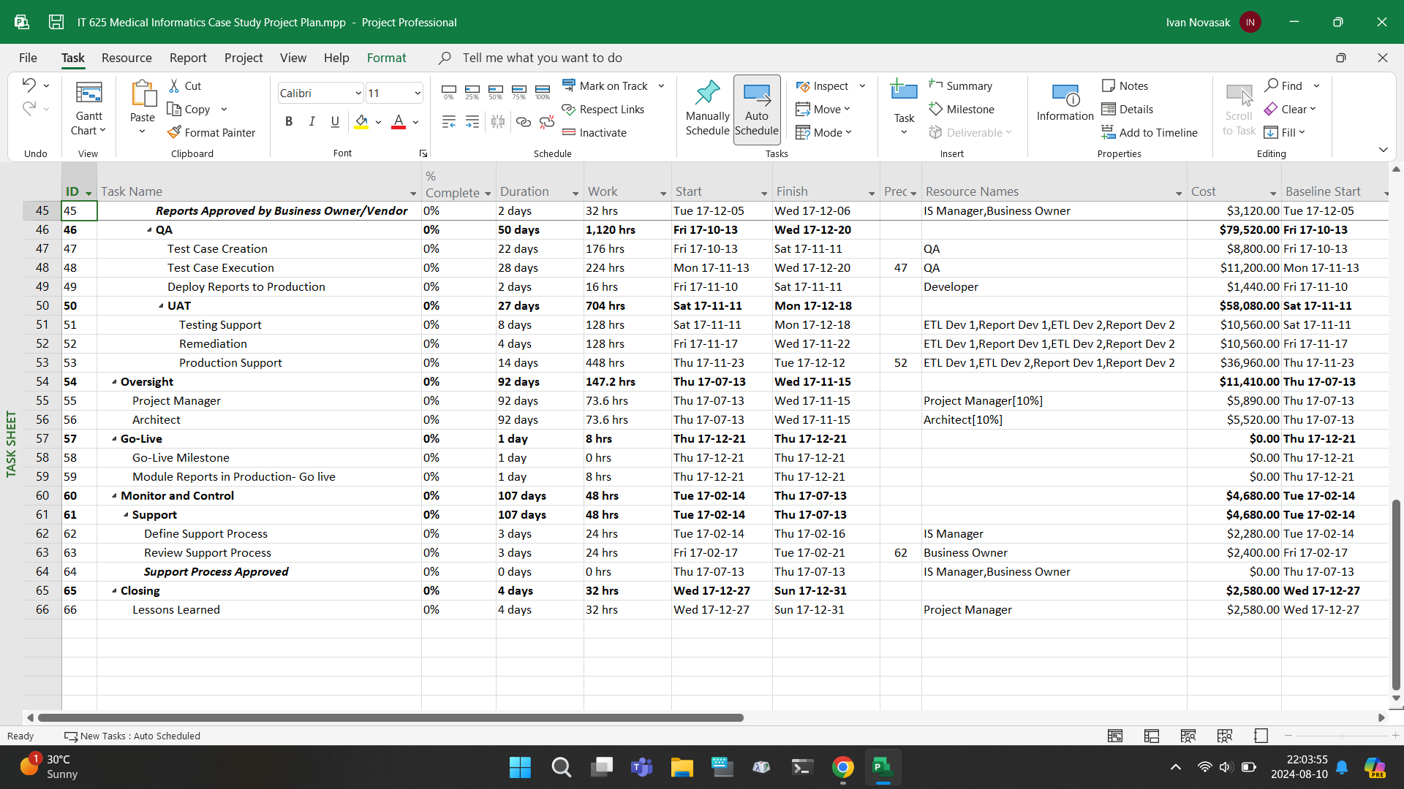

John Current, the project manager who had been assigned to take on this project, had to leave due to personal reasons after Module 2 was completed (Lamont, 2024a, p 3). The product developer executive, who also is this project’s sponsor, wanted the product launched as quickly as possible to launch before any competitors who may have the same idea for a wellness data incorporation (Lamont, 2024a, p 3). The project’s team members report to the project manager, and the project manager talks with staff at the other departments such as legal marketing, and operations (Lamont, 2024a, p 3).

***What stage of the 5-stage team development model is this team in?***

According to Wendy Lamont, the team has already been formed and has been working well within their defined roles with the early stages of development (Lamont, 2024a, p 4). The team has gotten to know one another and adjusted to their roles in the project. Once John Current (the project manager) left, the team began to have trouble communicating with each other and staying on task, with the architect and database administrators not being able to work together on how the database supports vendor reports (Lamont, 2024a, p 5). In addition, the programmers have been adding features based on widening customer requirements and the project’s full scope along with the different staff member’s exact roles were not defined in written form (Lamont, 2024a, pp 3/4). Writing all the requirements, roles, and task dependencies in advance would have been very helpful, should someone leave during the project as did John Current.

The team appears to be what the Mind Tools Content Team refers to as the Storming stage, which Bruce Tuckman says is a stage in team development where team members push against the boundaries of their roles and can cause friction and arguments in the team (Mind Tools, 2024). The team members can be overwhelmed when their roles and responsibilities are not explicitly defined (Mind Tools, 2024). In the case of Medical Informatics, the programmers did not have a list of requirements that was defined at the outset and instead were having requirements change at the whims of customers whenever they contacted Medical Informatics about adding new features (Lamont, 2024a, p 4).

***Conflict Causes***

The primary causes of this conflict appear to be poor communication and unrealistic performance expectations, which are noted as possible conflict causes by Fahad Usmani (Usmani, 2024). The poor communication stems from a) not having a written project requirements document that shows everything that was intended to be programmed into the new software, b) John Current not being more specific in the roles each resource plays in the project so the next project manager could easily take over, and c) not giving more training to the programmers before taking on the project (Lamont, 2024a, pp 1/4).

***Skills the Team is Lacking Based on Their Roles***

Table 1 shows a listing of the skills and relevant roles that need more development in the team based on (Lamont, 2024a).

**Table 1**

*List of skills needing improvement and relevant team member roles*

|  |  |
| --- | --- |
| **Skill** | **Team Member Role(s)** |
| MS Visual Studio programming language | Software developers |
| SQL | Software developers, Database administrator, architect |
| Teradata | Software developers, Database administrator |
| Writing a requirements specification | Architect |
| Project planning | Project manager |
| Recordkeeping / time logging / progress reporting | Report developers |
| Testing / debugging | Quality assurance, Software developers |
| Capturing reported issues | Technical support |
| Handling changes | Project manager, architect, software developers |
| Tracking total cost of ownership | Business analyst |

# Conflict Resolution Leadership

The next section covers how to resolve the conflict.

***Leadership Style for the Current Stage of Team Development***

According to Fahad Usmani, the ideal leadership style for the team at this stage (storming) is coaching (Usmani, 2022a). This is where the team’s manager is less authoritarian and instead the manager provides advice and support to develop the team members into their full potential (Usmani, 2022b). This leadership style also is about allowing the team members to mesh well to work with each other in concert as is the case in a sports team. Given the conflict between both the roles the team members have had and their duties as well as the technical aspects like not having a debugging system and lack of adequate training for the new development environment/programming languages, the conflict appears to be functional rather than dysfunctional, given there is no name-calling going on and the problems being experienced are not restricted to the members themselves (Larson & Gray, 2020, pp 412–414). The project manager, being in a coaching role, should first try mediation and arbitration to persuade the team members to work amongst themselves and find a way to accomplish the end goal together (Larson & Gray, 2020, pp 413/414).

***How to Determine Appropriate Skills (Soft and Hard) for Each Role***

A good way to determine the appropriate skills people should have for each role is to consider the management style known as ‘management by walking around’ (Larson & Gray, 2020, pp 365–367), which is where the project manager literally walks around the environment and talks to everyone involved one by one separately to get a good idea on how the project is going and who has been in charge of what over time, as well as what they may be having trouble with. The project manager must gain the trust of everyone that it is safe to talk about anything regarding the project and ask for help whether from them or an outside source.

***What strategies should resolve the conflict?***

Two strategies that should go a long way to resolving the conflict are compromising/reconciling and collaboration/problem-solving, as both strategies bring everyone together to speak their perspectives and then negotiate what needs to be emphasised then come to an agreement on which people oversee the different aspects of the conflict (Usmani, 2024). For instance, the issue with the database may be able to be addressed by the architect, the database administrators, and more general software developers, but which person and role are best for that specific area? If the problem is specific to the database, the database administrator logically appears to be the best person for that job, given their experience in working on databases.

# Motivation and Confidence

# According to Jennifer Harrity of the Indeed Career Guide, some other strategies for addressing the conflict that can resolve and prevent conflict include team-building activities, structuring goals in a pyramid that shows which goals depend on other goals being complete, celebrating successes on the team, and encouraging everyone to work together with empowerment in the team (Harrity, 2023). Communication should be encouraged and done often, with any issues that come up talked about early on before it may morph into a larger problem (Harrity, 2023). That emphasis on ‘we’ is important so that the team realises their contributions are part of something larger for the organisation (Harrity, 2023).

# Jayson Derby of Thomas International Ltd has further suggestions for developing high-performance teams that include having people of these different roles (Derby, 2024):

* Action roles: implementer, task leader, and finisher
* People/social skills roles: coordinator, team worker, resource investigator
* Intellectual roles: plant (problem solver, creative thinker), monitor/evaluator, specialists.

Derby also recommends mastering emotional intelligence and giving appropriate feedback for the team members’ contributions; members’ emotional wellbeing is important to recognise who is more likely to work best with different team members and on various parts of a project (Derby, 2024). Finally, he recommends setting ‘SMART’ (specific, measurable, achievable, realistic, timely) objectives (Derby, 2024). With the case of the software project, this may be implementing a feature freeze at whatever parts that are currently being worked on and continue to take customers’ suggestions for a future version of the software project.

# Project Evaluation

The next major section of this document is to evaluate and analyse the current status of the Medical Informatics Wellness Vendor project referenced in (Lamont, 2024a) so far, predict when the project will be finished at and what cost, describe what impacts the experience within the project will have it failing or succeeding, and any corrective actions that need to be taken to get this project back on track.

**Status Evaluation**

The author attached screenshots in Figures 1–3 in the Conflict Resolution Plan section of this document and the document entitled *Medical Informatics: Conflict Resolution Plan Draft* (Novasak, 2024a, pp 3–5) which shown a listing of all phases and tasks that were done and yet to be finished, along with their costs start and end dates, and percentage complete. According to the Gantt Chart in the figures, the following observations are indicated:

* The Wellness Vendor project began on 14 February 2017 (but also shows an initiation date of 4 May 2017) and was scheduled to end on 31 December 2017
* The project was 24% complete overall and had at least some work done on all tasks from the beginning till the conclusion of the Final Code Review-Module 2, which finished at the completion of the Validate Data Accuracy task on 12 October 2017.
* The total cost of the Wellness Vendor project is $234,124.00.

Reviewing the data in (Lamont, 2024a), it says the project start date (‘kickoff’) is 5 May 2017 and launch date was scheduled for 21 December 2017 (Lamont, 2024a, p 1). The author assumes that the sentence ‘The tasks that had been completed prior to May 5, 2017 were the business case compilation and approval and the project team establishment.’ is referring to the time gap between the project starting date of 14 February 2017 and the initiation date of 4 May 2017 shown in the Gantt Chart. The launch date of 21 December 2017 is indicated in the Gantt Chart as the ‘Go Live’ date. In (Lamont, 2024a, p 3), a date of 5 August 2017 was mentioned for a follow-up meeting for reviewing project plans. This tracks with the Gantt Chart which shows the following tasks taking place around that time (numeric dates in ISO 8601 yyyy-mm-dd format in start/end order):

* Project Plan (2017-07-15/2017-08-04)
* Resource Allocation Approvals (2017-06-11/2017-08-07)
* Develop Communications Plan (2017-07-29)
* Review/Approve Communications Plan (2017-07-31/2017-08-02)

For finances, (Lamont, 2024a, p 7) indicates the planned cost was $441,650, the actual cost to date was $230,892, remaining funds are $210,758, and the project was estimated at to cost $529,980, and is claimed to be 20% over budget (Lamont, 2024a, p 5). They also claimed the vendor requires a final payment of $75,000 for the third (final) module for this project, which was 75% of its cost (Lamont, 2024a, p 5). These figures are different to what the Gantt Chart shows, so a question about the discrepancy is whether the chart is why the difference between the Gantt Chart cost showing $234,124 vs (Lamont, 2024a, p 7) saying $441,650 for the total planned cost, a difference of $207,526.

**Project Analysis**

***Scope Creep Impact***

According to Larson and Gray, Scope creep is when a project’s scope expands over time beyond the original objectives by changing or adding requirements, specifications, or priorities (Larson & Gray, 2020, pp 110/111). These changes are typically sudden and will result in higher costs and a longer time to finish, as well as added testing benign required (Larson & Gray, 2020, pp 110/111). The most relevant causes of scope creep in this Medical Informatics Wellness Vendor project are poor requirement analysis, underestimating the project’s complexity, and a lack of change control that ensures only changes appropriate for this project get approved (Larson & Gray, 2020, p 110). The specific impacts of the scope creep for Medical Informatics were from added requirements created by customers being approved for programmers to continue adding in despite the deadline and their existing maintenance duties as evidenced in (Lamont, 2024a, p 4):

‘*Progress was not as fast as desired, due mainly to users changing their minds about the requirements. The programmers were very accommodating with such changes and tried their utmost to keep the users satisfied. Unfortunately, the number of changes and additional requirements requested by the users caused the work to fall behind schedule.*’

***Baseline Significance***

According to Wrike, a project baseline is ‘a fixed reference point to measure and compare your project’s progress against’ and has three reference points: cost, scope, and schedule (Wrike, n.d.). The project’s schedule depends on its required tasks, deliverables, objectives, and scope (Wrike, n.d.). This can all be tracked in a Work Breakdown Structure like a Gantt Chart such as what is shown in Figures 1–3 in (Novasak, 2024a, pp 3–5). The costs of the project depend on many factors that can include employees’ wages, any equipment that needs to be purchased, extra costs for training, and budgeting for emergency expenses (Wrike, n.d.). Having a baseline for a project helps track a project’s progress against the measures identified (tasks/deliverables, expenses/funding, and timeline) as well as identify if a project is going out of bounds with respect to that schedule or budget (Wrike, n.d.). Without a baseline, one can run into problems such as (Wrike, n.d.):

* Not knowing which resources to allocate and where they are best assigned
* Forgetting what order the tasks need to be done in or which items need to be procured and when
* Not being assured the project is in line with customers’ expectations
* Difficulties with reporting progress to upper management who likely wants regular reporting a project’s progress, since they are the ones procuring the funds for it

With Medical Informatics, the initial baseline appears to be (Lamont, 2024a, pp 1/7):

1. Schedule: 5 May 2017 to 21 December 2017 (7 months and 16 days)
2. Planned Cost: $441,650
3. Deliverable: ‘a modular software package to handle wellness vendor data to ensure appropriate preventative care is being tracked for members, including the systems changes, the vendor wellness database tables, and wellness vendor reporting’.

***Impacts of Baseline Change***

Wrike says that a baseline can be changed but it must not be taken lightly and is considered a formal process (Wrike, n.d.). Whatever changes are to be made in it need to be explicitly documented and considered with upper management carefully (Wrike, n.d.). The old baseline must be saved prior to changing it and will prove useful to measure against at project completion should the baseline need changing. Øyvind Røberg of Safran/JDM Technology Group says that if the baseline is changed/revised, only the changes from the current time forward must be shown and the past performance cannot be changed, which protects the historical integrity of performance in the project (Røberg, 2020).

***Estimated vs Actual Costs***

The planned cost for this project was $441,650 and the estimated cost as of 5 October 2017 was $529,980, which is $88,330 higher than planned (Lamont, 2024a, pp 4/7). An expected cost that was to come up very shortly after this report was written was a vendor cost of $75,000 for delivering the third module, wellness vendor reporting, for the project (Lamont, 2024a, pp 1/5).

**Forecasting**

***Assumptions that Guide Forecasting***

The following assumptions will be used for the forecasting of time and future costs:

1. The project’s pace will continue at the rate it was as of when it fell behind on 12 October 2017.
2. Funds will continue to be spent at the same rate it was prior, but with the $75,000 and remaining $25,000 required by vendor #3 included.

Note the time from 4 May 2017 to 12 October 2017, the duration of documented work on the project before John Current left, is 162 days if the 12th is included.

Some more financial data that is in (Lamont, 2024b, p 1/2) that will be useful is shown in Table 2:

**Table 2**

*Medical Informatics Wellness Vendor Project Finances*

|  |  |  |  |  |  |  |
| --- | --- | --- | --- | --- | --- | --- |
| **Spend Type** | **Total Approved Spend** | **Total Updated Spend** | **% Of Approved** | **Spend-to-Date** | **Remaining Spend** | **% Remaining** |
| **Capital Expenditures** | $277,988 | $50,446 | 18% | $54,458 | $223,531 | 80% |
| **Operating Expenses** | $163,662 | $225 | 1% | $3,825 | $159,837 | 98% |

***Projected End Date (Schedule Variance)***

According to Kevin D. Davis of KnowledgeHut, the schedule variance (SV) of a project is the difference between the actual completion date and the scheduled completion date (Davis, 2024). If this value is positive, the tasks were completed ahead of schedule and the project is concluded earlier than expected; if it is negative, the tasks were not completed on time and the project is behind / has finished later than expected (Davis, 2024). The schedule variance report is as follows, adapted from (Davis, 2024) using the dates in (Lamont, 2024a, p 1) and the Gantt Chart, and the assumption the project will continue at the same pace (24% completion after 162 days):

* Planned Completion Date: 21 December 2017
* Estimated Completion Date: 675 days after 4 May 2017, or 10 March 2019.
* Schedule Variance: Number of days between 21 December 2017 and 10 March 2019 is 445 days, so the project will be 445 days late on the current course.

Note: <<https://www.timeanddate.com/>> was used for the date-to-date calculations.

***Cost of Project Completion (Cost Variance)***

Kevin Davis states that the cost variance (CV) of a project is ‘the difference between the actual cost incurred and the planned cost for a specific task, activity, or entire project’ where a positive CV indicates savings, and a negative CV indicates overruns (Davis, 2024). One typically calculates this by the formula . In the case of Medical Informatics, the project was not completed, but one can use the given estimated cost in place of the actual cost to project the CV for the Wellness Vendor project as follows as adapted from (Davis, 2024):

* Planned Cost: $441,650
* Estimated Cost: $529,980
* Cost Variance: (Negative CV indicates a cost overrun)

Percentage variance: (negative percentage indicates a 20% overrun).

***Forecast Overrun at Project Completion (Estimates at Completion)***

It has been established without a change of course, the Wellness Vendor project will be completed 445 days date at a cost of at least $188,330 ($88,330 due to higher overall project costs + $75,000 + $25,000 between the outstanding costs for vendor #3) more than the original budget plan. This can put the Wellness Vendor project in jeopardy of not being first to launch as was the original plan and ‘the launch had to precede the launch of similar

products from competitors’ (Lamont, 2024a, p 1).

**Impact of the Past**

Lack of formal documentation about each person’s role in the project (Lamont, 2024a, p 1) was key to its failure because when the project manager left, there was no easy way for the new project manager to pick up the project and know who is responsible for what. In addition, having resources allocated and task dependencies written down (Lamont, 2024a, pp 1/2) in the .mpp file and in a separate series of paper documents for managers would have given the team a base to work from until a new project manager was found.

Whether to log the number of hours spent on a given task (Lamont, 2024a, pp 3/4) can work for and against a project depending on the type of work being done and management style. Ideally, this information would be recorded at the end of each working day by each employee but would not be used against them; the information would only be investigated as a guide for the project manager to see if a department needs another employee or specific employee needs help on their task.

Regarding the continuously changing requirements, upper management should have given a deadline to customers by which the feature set will be frozen so developers can work on the project and get the product out but allow requests to be reserved for a future iteration. This would have ensured programmers would not get too high a workload at an especially trying time given they were simultaneously learning new programming languages (Lamont, 2024a, pp 1/2/4). The transition to the new programming language could have gone more smoothly had Medical Informatics invested in hiring at least one experienced programmer in the new language as well as the old language so they could better explain the similarities and differences to the development team. Not doing this and instead relying on developers to get support from vendors (Lamont, 2024a, p 4) who may or may not each back out in time during a mission-critical project was a decision that could be considered penny wise but pound foolish because having comfortable developers is vital in ensuring they can work most efficiently - this includes getting them the help they need in learning an unfamiliar environment/language. This decision also affected the speed the software modules operated at because lack of adequate training in the new programming language caused the developers to code in a less efficient way than what otherwise could have been done had they been fluent or at least got formal training in it (Lamont, 2024a, p 4).

Had everyone’s roles been formally defined earlier, there may not have been any issues between the architect and the database administration (Lamont, 2024a, p 5) because each of them would already know their specific roles and one of them would have defined how the database was to be built.

Lack of a testing strategy, issues tracker, and implementation plan can also hinder progress because it makes it harder to track where problems are happening, wasting time on finding the problem first rather than already knowing where it is and so developers can just get straight to working on fixing it.

Leaving communications about the project’s progress and finances up to just the project manager’s word was not a good idea because after they left, there was no way for upper management to verify what the team accomplished and what still needs to be done, as well as their financial situation (Lamont, 2024a, p 5). It would have been easier had both a) more information was stored in the .mpp file and b) management had access to the file on a cloud server.

**Corrective Actions**

***Immediate Actions Required for Project Rescue***

It is recommended to first resolve the dispute between the architect and database administration so this portion of the module can be finished. Also, work with upper management and the most knowledgeable existing members of the project team to devise a new project plan with new dates to finish the remaining tasks with the goal of releasing a minimum viable product. Upper management will need to hire a software developer with experience in both Java and Microsoft Visual Studio as well as SQL to train the developers in Visual Studio and SQL so their code will be more efficient, and the modules will run faster. Before committing any new code into the project, develop a testing and reporting system - even if it is only a spreadsheet with a list of problems, discovery dates, and who discovered them. Finally, negotiate with upper management on the budget and see how much was spent and how much is remaining, as well as see about an increase to hire the new Visual Studio and SQL programmer.

***Target Dates for Project Rescue***

The following dates assume the project is resuming from the most recent date shown in the .mpp file of 12 October 2017:

* 31 October 2017: Resolve dispute between architect and database administration
* 18 October to 14 November 2017: Create new project plan with upper management that has new dates to finish the remaining tasks with the goal of releasing a minimum viable product
* 20 November to 22 December 2017: Hire and onboard new software developers experienced in Microsoft Visual Studio and SQL
* January 2018 onwards: Develop and maintain a testing/debugging/issue tracking system
* 2018 Qr 2 End: Launch Wellness Vendor product approximately 6 months behind schedule but still 265 days ahead of when the product would likely have launched with no changes.

***Necessary Steps to Ensure Long-Term Project Success***

According to John Brackett of Smash Balloon LLC and writing for *Forbes*, ensuring a project’s long-term success can be achieved in several ways such as (Brackett, 2022):

* Breaking a project down into smaller mini goals and milestones at the levels of 6 months, 3 months, monthly, and weekly by starting at the end date and working backwards to fill in progress requirements by dates (Brackett, 2022).
* Having a rewards system for finishing milestones on or ahead of time, like bonuses or other benefits for the employees and their families (Brackett, 2022). This can ensure employees stay motivated and on track with the project.
* Identify ways things can go wrong with the project and plan for it with contingencies in place (Brackett, 2022). For instance, with the absence of the project manager, upper management could have required the project manager to document the project’s working in case they are to be absent. For the programming language, when switching languages, considerations need to be made assuming not everyone is fluent in that language and how to deal with that.
* Have check-ins at the 30, 60, and 90-day marks with everyone to see how the project is progressing overall (Brackett, 2022). This timeline ensures one is not micromanaging but also it is good to assure the employees you are here for them if needed.
* Remember why this project is happening (Brackett, 2022). The employees on the team will be more motivated in the project if they know why it is happening. In the case of Medical Informatics, it is making a software product to ensure patients are getting the right types of preventative care (Lamont, 2024a, p 1).

**Project Charter**

The next section involves creating a new project charter for Medical Informatics that uses goals, needs, the project analysis, and corrective action requirements to bring the wellness vendor software to life. It is to include project objectives, strategy, and a communications plan.

**Project Objectives**

The project’s overall objectives that are yet to be completed will contain the same ones as in the Case Study and Project Charter documents (Lamont, 2024a, pp 1–3/6–7; Lamont, 2024c, pp 1–3) plus some new ones defined in (Novasak, 2024b, pp 11–13). From the original listing was (Lamont, 2024a, pp 1–3/6–7; Lamont, 2024c, pp 1–3):

* Complete programming
* Complete and get approval for project charter
* Start system testing
* Start planning for user acceptance test (compile test plan)
* Fix errors and omissions identified during testing
* Compile and agree on an implementation plan
* Progress reports fortnightly with progress summary, deliverables attained, percent complete, risks, issues, and cost information (ongoing)
* Get final policy document wording from legal department
* Make sure Testers are available for required testing dates
* Launch Wellness Vendor software on 21 December 2017

Some new objectives identified by the author of this document are (Novasak, 2024b, pp 11–13):

* Resolve the dispute between the architect and database administration
* Devise a new project plan with upper management and expert project members to release a minimum viable product (MVP)
* Feature freeze to complete whatever requested features were last being worked on to ensure MVP
* Hire software developers fluent in Java, SQL, and Visual Studio
* Train existing developers in SQL and Visual Studio
* Develop a testing and reporting system for handling bugs
* Negotiate with upper management on the budget and hiring the Visual Studio and SQL developer(s).

**Project Strategy**

***The Existing Problem(s): Description, Impacts, who is Affected, Costs of Ignoring the Problem***

In (Lamont, 2024a, pp 1–5), it was established that the following problems prevented a successful launch of the Wellness Vendor software:

1. Not officially defining the project’s reporting requirements and legal policy documents
2. Interfacing with the legal, marketing, and operations departments was left up to the project manager to handle on his own, with no plan for if he needed to leave as had eventually happened
3. Even though each phase and task for the project was defined, the specific resources and dependencies were not formally allocated, which would have made responsibilities clearer when the database conflict occurred
4. Not adequately defining the software’s requirements resulted in programmers continuously adding more and more features at customers’ requests despite the time limitations
5. Not enough training was offered in the new programming languages to allow programmers to design more efficient software
6. A conflict ‘between the architect and database administrators on just how the database supports the vendor reports’
7. No defined testing strategy, bug reporting system, or defined method for dealing with any needed changes
8. Team members working multiple roles, some of which were overlapping without clear responsibility
9. No communications plan, risk plan, system implementation plan, or total cost of ownership schedule.

The findings in (Novasak, 2024b, pp 7–9) indicate that the project on the track it was set to run at with these issues unresolved (ignoring the problems), would have finished 445 days behind schedule at a cost of at least $188,000 higher than projected at the outset. The time delay is especially concerning, because Medical Informatics intended to launch this software ahead of any possible competition launching a similar product. The ultimate impact was Medical Informatics was unable to launch the Wellness Vendor software, and as such, patients who could have benefited from the analytics this software would have provided did not and could have been mis-diagnosed or not diagnosed with a condition they may have had.

***Strengths and Weaknesses of the Internal Environment***

Despite the confusion and commotion that began when John Current (the project manager) left when the developers were making the third module and trying to decide how to design the database, the team members were working well together through the project’s first two modules (Lamont, 2024a, pp 4/5). The other strength was the programmers’ and John Current’s experience in working on software product development projects and high level of systems and applications knowledge (Lamont, 2024a, p 3).

The main weakness appears to be John Current and the team having relied on their experience and intuition and deciding to deal with the various matters involved in managing the project as they come, as opposed to trying to document up front the requirements and dependencies (Lamont, 2024a, p 3). They did not define a rigid enough scope and did not plan for the absence of any important people on the team, especially the project manager. It sounds like whenever there was a problem within the team, the project manager would sort it out with them.

***Opportunities and Threats in the External Environment***

The primary opportunity Medical Informatics has in launching their Wellness Vendor software early enough is the first-mover advantage, which is, according to Andrew Beattie of *Investopedia*, is when a company’s offering is the first of its kind into a market segment the company created a new market segment entirely (Beattie, 2023). Being first mover has the advantages of the network effect and economy of scale in that the company’s product can be popularised ahead of others' offerings debut (Beattie, 2023). That network effect also gets people familiar with the product even if they do not buy it which can still help it become dominant in the market. For the case of Medical Informatics, this could mean that medical providers may not be ready to buy yet but once they are, they will have them in mind due to being first in the industry to offer this product.

***The Best Solution to the Problem***

The solution outlined in (Novasak, 2024b, pp 11–13), plus fixing all the points noted in The Existing Problem(s) section of this document, will be the way to go. It begins with documenting the roles and responsibilities of everyone involved with the project, as well as which tasks they oversee.

***The Project Payback Period***

According to Laurel Tincher of *SoFi Learn*, the payback period of a project is defined as ‘is the amount of time it will take to recoup the initial cost of an investment, or to reach its break-even point’, and can be calculated in two different ways: the averaging method or the subtraction method (Tincher, 2023). The averaging method is calculated as follows: where *p* is the payback period, *i* is the initial investment and *y* is the yearly cash flow in dollars or the currency being used per year (Tincher, 2023). This method is ideal for investments that are expected to have a steady stream of income every year and not wildly fluctuate from year to year (Tincher, 2023). They have an example for calculating this where they compare two investment options that had a million-dollar investment each where one investment generated $250,000 per year in revenue and the other generated $280,000 per year. For the first investment, the calculation is: 4 years. For the latter investment this is approximately 3.57 years, so the latter investment appears to be better according to this calculation due to it having a shorter payback period (Tincher, 2023).

The second method, known as the subtraction method, is calculated as follows: , where *p* is the payback period, *n* is the last year of negative cash flow (since the year the project began), *a* is the amount of cash flow at the end of that year, and *d* is the cash flow during the year after that year (Tincher, 2023). Tincher has an example for calculating this too assuming an initial investment of $550,000 and is a bit more complicated, but it is shown in Table 3 (Tincher, 2023):

**Table 3**

*Payback Period Calculation: Subtraction Method*

|  |  |  |  |
| --- | --- | --- | --- |
| **Elapsed Time (Years)** | **Expected Cash Flow ($)** | **Calculation** | **Result** |
| 0 | 0 | 0 - 550,000 | -550,000 |
| 1 | 75,000 | -550,000 + 75,000 | -475,000 |
| 2 | 140,000 | -475,000 + 140,000 | -335,000 |
| 3 | 200,000 | -335,000 + 200,000 | -135,000 |
| 4 | 110,000 | -135,000 + 110,000 | -25,000 |
| 5 | 60,000 | -25,000 + 60,000 | 35,000 |

*NOTE*: Data are from (Tincher, 2023).

For the example calculation, *n* would be 4, as it is the last year with negative cash flow; *a* would be 25,000 which is the amount of cash flow for that year, and *d* would be 60,000 which is the cash flow for the next year (year 5). Using the formula, the payback period is approximately 4.42 years (Tincher, 2023).

The upside to these formulas is that it is relatively straightforward to compare investments and see which has a faster time to break-even (Tincher, 2023). The downside is neither can tell how well the investment will perform after the payback period is over (Tincher, 2023).

For Medical Informatics, the payback period cannot yet be calculated as things currently stand, because there exist no expected revenues in the reports; only invested amounts.

**Project Communications Planning**

***Which parties need to be informed and are best equipped to make decisions for this project?***

This question is best answered by first starting with a screenshot of the .mpp file that was included with (Lamont, 2024a):

**Figure 4**

*Microsoft Project screenshot showing Medical Informatics project resources*

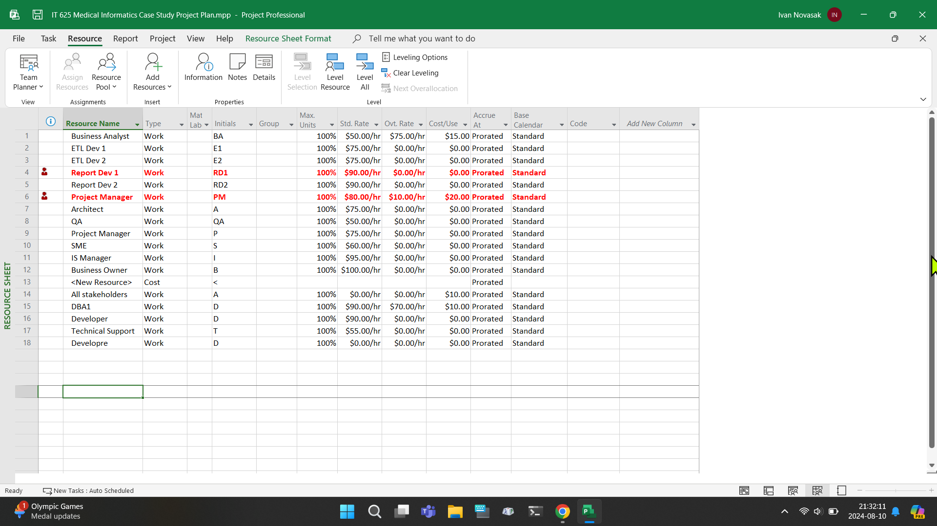

There are some other departments and people listed in (Lamont, 2024a/b), which are:

* Sue Barrett (Sponsor)
* Roy Kirk
* Kevin Smith
* Legal Department
* Marketing
* Operations
* User Department
* Management
* Vendors
* Project Owner (Sr VP Operation Systems)
* VP Operations
* Customer service IT support

Table 4 contains a possible design for the roles and responsibilities of the team members based on the roles defined by Alicia Schneider of monday.com (Schneider, 2023).

**Table 4**

*Roles and Responsibilities*

|  |  |  |  |
| --- | --- | --- | --- |
| **Team Member/Role** | **Responsible For** | **Reports To** | **Signs off on decisions?** |
| Sue Barrett, Sponsor | Ensuring project is following with business goals/strategy, providing final say on major decisions, giving financial resources, overseeing the team’s effectiveness, monitoring milestones, collecting feedback at conclusion | Upper Management, Legal Dept, Operations | Yes |
| Project Owner (Sr VP Operation Systems) | Bridging communication between Sue Barrett and the project manager, approve project changes | Sue Barrett & Project Manager | Yes |
| Project Manager | Creating the project plan, monitoring daily progress for each milestone in the timeline, ensuring project is finished on time and within budget, creating each deliverables’ details, hiring new programming language employees to train developers, meeting with employees to discuss whether any assistance is needed to complete deliverables | Sue Barrett & Project Owner | Yes |
| Legal Dept | Creating legal documents for Medical Informatics | Sue Barrett, Upper Management | Yes, only for their dept |
| Marketing | Creating promotional material for Medical Informatics wellness vendor software | Project Owner & Legal Dept | Yes, only for their dept |
| User Dept | Getting users’ requests and sending them to the project manager for either approval or denial, explaining reasoning for possible denial to users | Project Manager | No |
| Customer services IT support | Using technical support hotline and chat system to talk to end-users who purchased wellness vendor software and need help with it | Product Owner | No |
| Vendors | Supplying equipment or outside software for Medical Informatics to use during the project | Project Manager & Sue Barrett | No |
| Architect | Defining the features to be incorporated in the wellness vendor software, meeting with developers & PM for checking deliverables’ progress | Project Manager | No |
| Software Developers | Programming features for wellness vendor app | Project Manager | No |
| Business Analyst | Ensure project is within budget, verify financial accountancy and financial reports | Project Owner | No |
| Database Admins | Creating and managing the software’s database system | Project Manager | No |

***When will the information be provided?***

Each category of information has its own time intervals that are ideal for communicating. Table 5 lists each category and the time interval between each category’s communication and involved parties.

**Table 5**

*Type of information communicated, involved parties, and how often*

|  |  |  |
| --- | --- | --- |
| **Time Interval** | **Involved Parties** | **Information Type(s)** |
| Quarterly | Sue Barrett, Project Owner, Upper Management, PM, Business Analyst | Overall progress, milestone completions, scope & timeline alterations, budget updates, accountancy |
| Monthly | PM, Architect, Marketing, Senior SW Developers, vendors | Progress on product features, promotion of finished features, decisions on which developers handle which scope items, vendor orders for outside products |
| Fortnightly | PM, SW Developers, database administration | Overall progress on milestone, requests for assistance |
| Weekly | PM, SW Developers, database administration | Specific features’/tasks’ progress |
| 2 to 3 times per week | SW Developers, database administration | Code commits |

***What information is most pertinent to the stakeholders who contribute to the project’s progress (scope changes, action items, deliverables issues)?***

This information can be gleaned from Table 5 in the Involved Parties and Information Type(s) columns. In general, upper management, the sponsor, the legal department, marketing, business analyst, and product owner want to know mostly about the overall progress of the wellness vendor software as a whole and will be willing to help procure funds or other resources, such as the training for the developers to learn the new programming language, and how much this is costing the company and how much profit can be realised. End-users/customers are mostly concerned with when it will launch and what features it will have; not much else. The project manager, database administration, software developers, and architect are most concerned with the day-to-day and month-to-month progress on each individual feature and how those work together to form the overall software. Examples here would be the three milestones and resolving the database functionality concerns.

***Where will this information be stored?***

According to Melanie Pinola of Zapier, Microsoft Office 365/One Drive, Slack, Zoom, TeamViewer, digital notetaking, and cloud storage apps are must-haves for digital file sharing and collaboration during online projects like this wellness vendor software (Pinola, 2020). If the team has more Windows-based hardware, it is recommended to go with Microsoft’s 365 Office suite including OneDrive for writing documents, spreadsheets, and presentations (Pinola, 2020). Any secure cloud storage service will work fine (Pinola, 2020), and the author has experience using Google Drive and Dropbox. Zoom and Slack are essential for video conferencing meetings and code sharing amongst the developers - especially any staff who are working at multiple locations (Pinola, 2020). Given the new programming languages the developers are being trained to use (Lamont, 2024a, p 1), it is recommended to use Windows-based computers and the Microsoft Office suite. OneDrive, which is part of this suite, provides cloud storage as well.

***How will the information be collected?***

Developers will use Slack rooms/channels or whatever existing code collaboration software they currently use for their day-to-day sharing of the code they create with each other. Online meetings will take place using Zoom and TeamViewer, depending on which software Medical Informatics are most familiar with using (both provide screen sharing capabilities). Zoom has proven to be the most reliable at Zapier for meetings with large numbers of attendees that may need to take place amongst Medical Informatics wide-ranging staff, so this app is recommended (Pinola, 2020). It is recommended to record these meetings in case someone is ill and cannot attend one of the meetings. Zoom offers this capability. Note-taking from these meetings for the minutes documents can be done via Google Keep, Evernote, OneNote, or another note-sharing software or service. It is recommended to write minutes for every meeting, as opposed to before where minutes were written for only some meetings (Lamont, 2024a, p 4). The minutes and other important documents pertaining to the software will be written in Microsoft Word documents and stored in the cloud storage account, with credentials sent to all relevant staff ahead of time. At the end of everyone’s workday, their code and other work must be uploaded to the Slack channel or cloud storage app Medical Informatics is using in case of hardware issues.

# Scope, Cost, and Quality Planning Report

The next section of this document is for planning out a revised scope, costs analysis, and defining how to tell if the project is of high quality. The revised scope is to include a listing of requirements with a traceability matrix and responsible parties via an assignment matrix. For costs, a cost-benefit analysis, total cost or ownership, budget comparison for actual vs budgeted costs, and earned value. For analysing quality, key performance indicators, important factors, and measures of quality are defined.

# Project Scope Planning

***Requirements (with the Requirements Traceability Matrix)***

According to Lauren Good of Project-Management.com, a requirements traceability matrix (RTM) is mainly used for technical software and hardware projects and tracks ‘project requirements, their status towards completion, and a record of each test that has been run for each requirement’ (Good, 2024a). Other elements that could be included are dates, source, requirement name and description, who it was assigned to, what the acceptance criteria is, who tested it and what date, and who accepted it and on what date (Good, 2024a). It is usually used to track feature progress and elimination of bugs (Good, 2024a). The data for the Medical Informatics RTM will originate from the .mpp file/Gantt Chart included with (Lamont, 2024a) as well as the new objectives identified by the author in (Novasak, 2024b/c). Table 6 shows the RTM for Medical Informatics.

**Table 6**

*Medical Informatics Requirements Traceability Matrix*

|  |  |  |  |  |  |  |  |
| --- | --- | --- | --- | --- | --- | --- | --- |
| **Project Name** | Wellness Vendor |  | **Date** | 2024-09-06 |  |  |  |
| **Project Manager** | Ivan Novasak |  | **Project Owner/Client** | Sr VP Operation Systems |  |  |  |
|  |  |  |  |  |  |  |  |
|  |  |  |  |  |  |  |  |
| **Task/Requirement Number** | **Date Received** | **Source** | **Requirement name & Description** | **Assigned To** | **Acceptance Criteria** | **Tested By & Date** | **Accepted By & Date** |

|  |  |  |  |  |  |  |  |
| --- | --- | --- | --- | --- | --- | --- | --- |
| 5 | 2017-05-04 |  | Budget Dollar Service Request | IS Manager |  |  |  |
| 6 | 2017-06-03 |  | Project Charter | Business Owner |  |  |  |
| 7 | 2017-06-02 |  | Obtain Approvals | IS Manager |  |  |  |
| 9 | 2017-07-15 |  | Project Plan | John Current |  |  |  |
| 10 | 2017-06-11 |  | Resource Allocation Approvals | John Current |  |  |  |
| 12 | 2017-07-29 |  | Develop Communication Plan | John Current |  |  |  |
| 13 | 2017-07-31 |  | Review/Approve Communication Plan | John Current & SME |  |  |  |
| 18 | 2017-08-10 |  | Create/Modify Vendor Database Tables | DBA1 |  |  |  |
| 19 | 2017-10-12 |  | Promote Tables to QA | DBA1 |  |  |  |
| 20 | 2017-10-05 |  | Validate Tables (for creation) | DBA1 |  |  |  |
| 21 | 2017-10-05 |  | UAT | Business Analyst |  |  |  |
| 23 | 2017-09-16 |  | Create Production Ticket SR# | Business Analyst |  |  |  |
| 24 | 2017-10-19 |  | Deploy Tables | DBA1 |  |  |  |
| 25 | 2017-10-20 |  | Validate Tables (for promotion to production) | Business Analyst |  |  |  |
| 27 | 2017-09-07 |  | Module 1 Code Review | Developer |  |  |  |
| 28 | 2017-10-09 |  | Validate Data Accuracy (Module 1) | Business Analyst |  |  |  |
| 30 | 2017-09-07 |  | Module 2 Code Review | Developer |  |  |  |
| 31 | 2017-10-09 |  | Validate Data Accuracy (Module 2) | Business Analyst |  |  |  |
| 33 | 2017-10-05 |  | Module 3 Code Review | All stakeholders |  |  |  |
| 34 | 2017-11-14 |  | Validate Data Accuracy (Module 3) | Business Analyst |  |  |  |
| 37 | 2017-07-13 |  | Define Business Rules | Business Analyst & John Current/Ivan Novasak |  |  |  |
| 38 | 2017-09-28 |  | Data Mapping | Business Analyst & John Current/Ivan Novasak |  |  |  |
| 39 | 2017-10-17 |  | Report Mockups | Business Analyst & John Current/Ivan Novasak |  |  |  |
| 40 | 2017-10-19 |  | Documentation & Current Mockup Layouts | Business Analyst & John Current/Ivan Novasak |  |  |  |
| 43 | 2017-10-31 |  | Report File Layout Data Mapping | Report Dev 1 |  |  |  |
| 44 | 2017-12-13 |  | Report UAT | Report Dev 1 |  |  |  |
| 45 | 2017-12-05 |  | Reports Approved by Business Owner/Vendor | IS Manager, Business Owner, Vendor |  |  |  |
| 47 | 2017-10-13 |  | Test Case Creation | Quality Assurance |  |  |  |
| 48 | 2017-11-13 |  | Test Case Execution | Quality Assurance |  |  |  |
| 49 | 2017-11-10 |  | Deploy Reports to Production | Developer |  |  |  |
| 51 | 2017-11-11 |  | Testing Support | ETL Devs 1 & 2, Report Devs 1 & 2 |  |  |  |
| 52 | 2017-11-17 |  | Remediation | ETL Devs 1 & 2, Report Devs 1 & 2 |  |  |  |
| 53 | 2017-11-23 |  | Production Support | ETL Devs 1 & 2, Report Devs 1 & 2 |  |  |  |
| 55 | 2017-07-13 |  | Oversight: Project Manager | John Current/Ivan Novasak |  |  |  |
| 56 | 2017-07-13 |  | Oversight: Architect | Architect |  |  |  |
| 62 | 2017-02-14 |  | Define Support Process | IS Manager |  |  |  |
| 63 | 2017-02-17 |  | Review Support Process | Business Owner |  |  |  |
| 64 | 2017-07-13 |  | Support Process Approval | IS Manager & Business Owner |  |  |  |
| 66 | 2017-12-27 |  | Lessons Learned | Ivan Novasak |  |  |  |
| NEW: |  |  |  |  |  |  |  |
|  | 2017-10-31 |  | Resolve dispute between architect and database administration | Architect, DBA1, Ivan Novasak | Vendor interactions w/ DB system is resolved so DBA can finish DB coding, no further conflicts | N/A | Ivan Novasak, 2017-10-31 |
|  | 2017-10-18 |  | Create new project plan with upper management that has new dates to finish the remaining tasks with the goal of releasing a minimum viable product | Ivan Novasak, Upper Management | New plan to get MVP out by 2018-06-30 | N/A | Upper Management, 2017-11-14 |
|  | 2017-11-20 |  | Hire and onboard 3 new software developers experienced in Microsoft Visual Studio and SQL | Ivan Novasak, Architect, Upper Management | Employ 3 new s/w devs to both work on this project and train existing devs in MS VS & SQL | N/A | Architect & Upper Management, 2017-12-22 |
|  | 2017-12-01 |  | Training commences | MS VS & SQL Devs, Existing Devs | Training complete & existing devs up-to-speed on MS VS & SQL; New devs able to help w/ Wellness Vendor project | N/A | Ivan Novasak & Architect, 2017-12-29 |
|  | 2017-11-01 |  | Draw up new legal documents | Legal team, Sponsor, Ivan Novasak | New legal documents complete |  | Legal team & Upper Management, 2017-11-30 |
|  | 2018-01-03 |  | Develop and maintain testing/debugging/issues tracking system | Quality Assurance, IS Manager | New system deployed to track bugs, test results, & other issues in s/w | N/A | IS Manager & Ivan Novasak, 2018-01-31 |
|  | 2017-10-16 |  | Negotiate with upper management budget to see how much was spent and how much is remaining, and see about an increase to hire the new Visual Studio and SQL programmers | Ivan Novasak, Upper Management, Architect | New higher budget to hire 3 MS VS & SQL devs | N/A | Upper Management/Sponsor, 2017-10-31 |
|  | 2017-11-01 |  | Post job ads to seek out 3 new MS VS & SQL devs | Ivan Novasak, Architect, IS Manager | Interview candidates | N/A | IS Manager & Sponsor, 2017-11-17 |
|  | 2018-06-01 |  | Launch Wellness Vendor Software | Upper Management, Ivan Novasak |  | N/A | Ivan Novasak / Sponsor / Upper Management / Quality Assurance, 2018-06-29 |

*NOTE*: Adapted from (Good, 2024a). The new entries created by the author are under #66 and are based on the objectives stated in (Novasak, 2024b).

***Who is responsible for each requirement (with the Responsibility Assignment Matrix)?***

According to Lauren Good, a Responsibility Assignment Matrix, also known as a RACI Chart, is for listing all involved parties in the project (or sub-project) and whether they are responsible, accountable, consulted, or informed for each task or activity (Good, 2024b).

Responsible parties are the people who typically directly do the jobs needed for the product to function, such as writing computer code, drawing interfaces, or manufacturing hardware (Good, 2024b). Good says some examples of responsible parties include project managers, business analysts, developers, graphic designers, and copywriters (Good, 2024b).

Accountable parties are the next step up and are parties who see to it that the project’s objectives are accomplished on time, within budget, and perform the functions that the company or organisation set out to develop (Good, 2024b). Good’s examples of accountable parties include product owners, signature authorities, business owners, sponsors, and key stakeholders (Good, 2024b).

The next category, consulted people, are vital to a project and are the people the responsible and accountable parties speak with when something is unclear; they are often experts in the fields they work or study in (Good, 2024b). Good lists some examples of consulted parties which are: legal experts, cyber/information security experts, and compliance consultants (Good, 2024b). The responsible and accountable parties must consult with these individuals frequently to ensure the product is functioning exactly as intended and has no errors or anything overlooked in development before manufacture or shipment (Good, 2024b).

The final category in the Responsibility Assignment Matrix, informed parties, are people who need to be aware of the project’s progress but have less control over the outcome and need more in the way of generalities (Good, 2024b). They typically receive updates and may be invited to promotional or demo events where the product and associated progress could be shown off (Good, 2024b). Good says some of these parties may include project committee members, external stakeholders, and business owners (Good, 2024b). Figure 5 shows a Responsibility Assignment Matrix for Medical Informatics concerning the new tasks the author has added to the scope list. The matrix spreadsheet file is included in .xml format with this document as well.

**Figure 5**

*Screenshot of Responsibility Assignment Matrix/RACI Chart for Newly Defined Tasks*

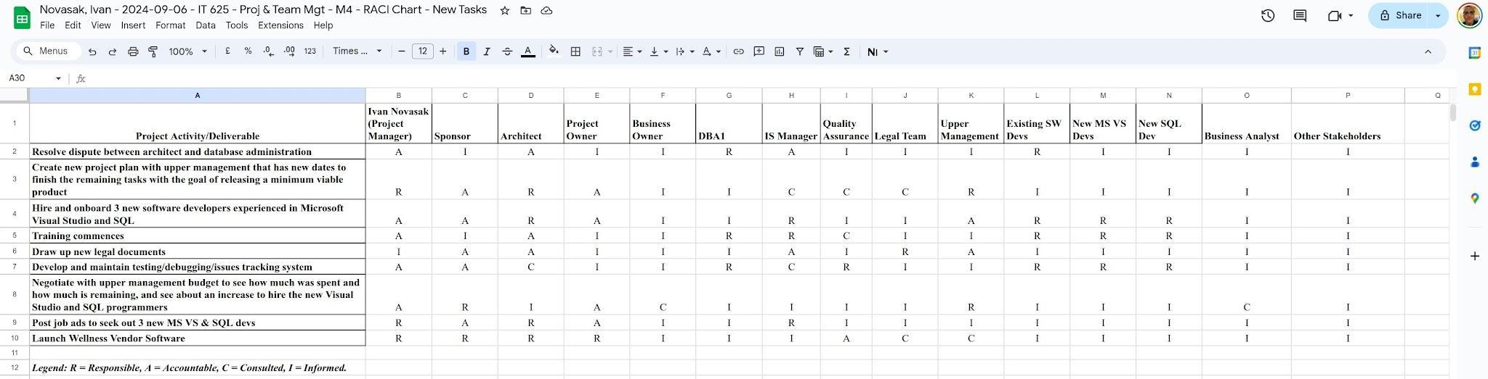

*NOTE*: Adapted from (Good, 2024b). Legend: R = Responsible, A = Accountable, C = Consulted, I = Informed.

**Project Cost Planning and Control**

***Cost-Benefit Analysis***

Peter Landau, of ProjectManager.com, Inc, presents the cost-benefit ratio formula as , where *r* is the ratio, *b*, is the total benefits (revenue), and *c* are the total costs (expenses) (Landau, 2023). If this ratio is greater than 1, the project is a worthy investment because there will be profit (Landau, 2023). To get an accurate ratio, one needs an accurate budget first (Landau, 2023). The items one typically needs to consider are as follows (Landau, 2023):

* Costs
  + Direct Costs
  + Indirect Costs
  + Intangible Costs
  + Opportunity Costs
  + Costs of Potential Risks
* Benefits
  + Direct Benefits
  + Indirect Benefits
  + Total Benefits
  + Net Benefits

Some of these values are known and itemised already by category, thanks to the .mpp file included with (Lamont, 2024a). To get an estimate of the total costs of the project, one needs to first tally the number of people involved, including new hires, and the amount of time the new tasks will take to finish along with the continuation of the original tasks. PayScale, Inc. and Talent.com list average and highest typical wages in New York for various job positions which will be used to calculate the new hires’ annual salaries for the project (PayScale, n.d.; Talent.com; ZipRecuiter, 2024; Glassdoor, 2024). The list is as follows:

* Project Manager: $129,000 (PayScale, n.d.)
* Software Developer: $150,000 (PayScale, n.d.)
* Software Architect: $158,200 (Talent.com, n.d.)
* IS Manager: $187,550 (Talent.com, n.d.)
* Database Administrator: $145,600 (Telent.com, n.d.)
* Upper Management (Senior Manager): $263,836 (Glassdoor, 2024)
* Legal team (Corporate Lawyer): $190,400 (ZipRecruiter, 2024)
* Project sponsor: $122,501 (ZipRecruiter, 2024)

The tally for all wages per activity are shown in Figure 6.

**Figure 6**

*Wages by Activity and Employee*

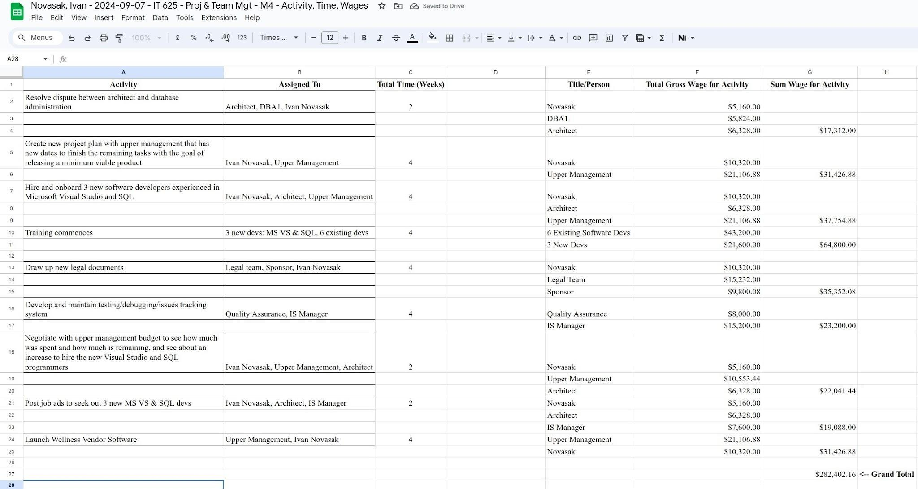

*NOTE*: Spreadsheet in .xls format is included with this document.

The value under Grand Total, $282,402.16 would be considered expected new wage expenses due to both the hiring of new employees and extension of the project to late June 2018 and are an example of direct costs. If the itemised expenses from the .mpp file in (Lamont, 2024a) are included too, the total itemised expenses become which is still within the estimated amount of $529,980 shown in (Lamont, 2024a, p 7), though that estimate did not anticipate hiring three new developers and having the project continue another six months. In the worst-case scenario so far, it appears the cost will be .

According to Pat Walls of Starter Story, a software company can make an average of $2.13 million per year in revenue, with ‘average weekly revenue for a software company ranges around [$44,500]’ (Walls, 2024). Using this figure as a guide, Medical Informatics can expect to earn $44,500 per week and so can recover their direct costs of $516,526.16 in 11.6 weeks, or 81 days. Using the cost-benefit ratio for a full year of revenue, through 30 June 2019 under the assumption the project will now finish in June 2018, at the cost $516,526.16 the ratio is: , a positive value and an indicator that the project should go ahead.

***Total Cost of Ownership***

According to Stephen J. Bigelow and Katie Terrell Hanna of TechTarget, the total cost of ownership or TCO ‘quantifies the cost of the purchase across the product's entire lifecycle’ and ‘is an estimation of the expenses associated with purchasing, deploying, using and retiring a product or piece of equipment’ (Bigelow & Hanna, 2021). It factors in all costs across the product’s full life cycle as opposed to using the purchase price alone (Bigelow & Hanna, 2021). Bigelow and Hanna also state the formula for return on investment (ROI), which is:

. For Medical Informatics using the values already used in the cost-benefit ratio, the ROI is for the first year.

***The Budgeted vs Actual Costs***

The original budget stated in (Lamont, 2024a, p 7) was $441,650 with an estimate of needing a total of $529,980 as of the 20% completion mark. The new direct costs of $516,526.16 for making the recommended project changes would require a similar budget increase request, though other expenses such as any indirect expenses, insurance, software subscriptions, and any further equipment costs need to be defined. Either way, if Medical Informatics can make the $44,500 per week off this new software that Pat Walls claimed (Walls, 2024), many expenses will be covered within the first year of revenues. The budget can be tracked using Microsoft Project as that is where many existing costs were itemised. The business analyst should monitor these numbers and compare them with the accountants so that there is little or no discrepancy. Alert the accountant and project manager if actual expenses are greater than 10% of budgeted expenses in any given month to try to see what the source is and if it is necessary.

***The Earned Value of this Project***

According to V. Vasiliauskas of Teamhood, the earned value of a project is defined as ‘the estimated monetary value for the work that has already been completed’ (Vasiliauskas, 2024). They calculate it using the formula (Vasiliauskas, 2024). For Medical Informatics using the work percentage completed in (Lamont, 2024c) along with the new budget, the earned value is calculated as:

.

**Project Quality Planning**

***Key Performance Indicators of Quality***

According to Gabriel Salles of Qualityweb 360, quality key performance indicators (KPIs) are measurements one can take that allow evaluation of a ‘company’s performance in terms of quality and provide you with valuable information to make informed decisions and continuous improvement’ (Salles, 2023). Examples of the different types of quality KPIs include process efficiency, customer satisfaction, product quality, and response time indicators (Salles, 2023). Process efficiency measures how fast an organisation or company performs their line of business or makes their products as well as how efficient they are at utilising their resources Examples of process efficiency KPIs would be ‘cycle time, resource utilization and workflow efficiency’ (Salles, 2023). Customer satisfaction is a second type of quality KPI and tracks how happy customers are with the organisation (Salles, 2023). It measures data such as ‘customer retention rate, customer satisfaction rating, and number of complaints or claims received’ and is likely the top type of KPI the average consumer is familiar with due to business ratings on consumer websites (Salles, 2023). The third type of quality KPI is product quality indicators and covers categories such as ‘defect rate, conformity to quality standards and product durability’ (Salles, 2023). This category is especially vital to companies who own factories and need to know which one needs to make improvements to their manufacturing processes and product quality KPIs help define acceptable baselines. The fourth and final type of quality KPI is response time indicators, which covers how quickly a company or organisation responds to customer requests or problems with the product or service (Salles, 2023). Categories that fit this type of KPI include ‘average response time, problem resolution time and turnaround time’ (Salles, 2023). All four of these types of KPIs have usefulness at Medical Informatics and could not be measured without an issue tracking or ticketing system in place, so once that is established, it will be easier to incorporate measuring these KPIs into the ticket system too.

There are five steps that are important for measuring quality KPIs which are as follows (Salles, 2023):

1. Define the objectives: Choose what types of KPIs are needed to discuss why (Salles, 2023). Knowing what needs to be accomplished comes first so one can decide which metrics are relevant.
2. Choose the right metrics and ensure that whatever metrics are chosen, they are ‘relevant, quantifiable and measurable’ (Salles, 2023).
3. Collect the data: This part can involve a variety of options. Tallying trouble ticket results and conducting surveys can be some example measurement practices for response time and customer satisfaction, respectively (Salles, 2023).
4. Analyse the data: This comes after the data has been collected and will be analysed using statistical or data analysis tools like Excel or the R programming language. This is the step where the findings from the measurements are revealed and corrective actions can be defined (Salles, 2023).
5. Taking corrective actions for improvement, based on what the analysis revealed: this can involve ‘implementing process changes, training personnel, or improving products or services’ (Salles, 2023).

According to Tricia Jessee of ClearPoint Strategy, one of the four pillars of project management KPI success is using the SMART Framework, which has goals that are ‘Specific, Measurable, Achievable, Relevant, and Time-bound’ (Jessee, 2024). The other pillars Jessee recommends are to prioritise a few essential metrics and not measure too many things; set realistic targets by utilising historical data, expert insights, or industry benchmarks; and refine the use of KPIs to select the pens which are most relevant at the time (Jessee, 2024). This includes discarding a KPI in favour of selecting a new one if needed (Jessee, 2024). The quality KPIs Jessee lists that were not in Salles’ listing include:

* Stakeholder Satisfaction
* Net Promoter Score: Defined as ‘a single-question survey to gauge brand loyalty’ and ‘indicates how likely customers are to recommend your services to others’ (Jessee, 2024). It is calculated as (Jessee, 2024).
* Error count
* Employee Churn Rate: This is defined as ‘the number or percentage of team members who leave the company during the project’ and could ‘indicate problems with management or work environment, ultimately slowing down the project and increasing costs’ (Jessee, 2024). The formula for calculating the churn rate is (Jessee, 2024).

***Important Factors in Defining Quality***

Now that quality KPIs are defined, the next step is to note which ones are most effective at Medical Informatics. The most logical KPIs to use are error/trouble ticket count, resolution/response time, finish time per task, stakeholder/customer satisfaction, customer retention rate, and customer satisfaction rating. The satisfaction ratings can be measured by conducting surveys regularly (Jessee, 2024) and the other ratings by automated processes found in the app that tracks bug tickets and responses as well as the tasks to be done.

***How to Measure Quality***

For tracking resolution and response times, as well as the finish time per task, the opening time for the defect/bug/request ticket will be taken as the start time and once the ticket is resolved, it will be closed, noting the closure time. The difference between these two times will be the resolution/response time. A similar measurement strategy will be used and start once the task is beginning and ending once the task is complete (100% of work done). For tracking customer and stakeholder satisfaction, the SurveyMonkey platform will be used to create and conduct surveys. It has been proven reliable with over 300,000 organisations trusting them globally and is compliant with HIPAA, the US healthcare data/privacy law (SurveyMonkey, n.d.).

# Project Schedule Planning, Risk Planning, and Risk Control Report

The upcoming section is to lay out the revised schedule for the Wellness Vendor project by Medical Informatics, defining risks to the project, and planning for how to deal with said risks. A revised Microsoft Project .mpp file with the new tasks and dates given in (Novasak, 2024d, pp 7–10) is enclosed with this document.

**Project Schedule Planning**

Figures 7–10 show the new listing of tasks and any that depend on one another. Other dependencies (for existing tasks) were added based on the dates and type of task. The tasks were automatically re-numbered in Microsoft Project. Tasks that can either be performed in parallel with others or where the dependencies are unknown have the Predecessors cell for that task left empty. Note that all numeric dates are displayed in YYYY-MM-DD or YY-MM-DD format (e.g., 2017-06-14 or 17-06-14 for 14 June 2017).

**Figure 7**

*Microsoft Project screenshot showing a listing of the beginning of the project: tasks #1–23.*

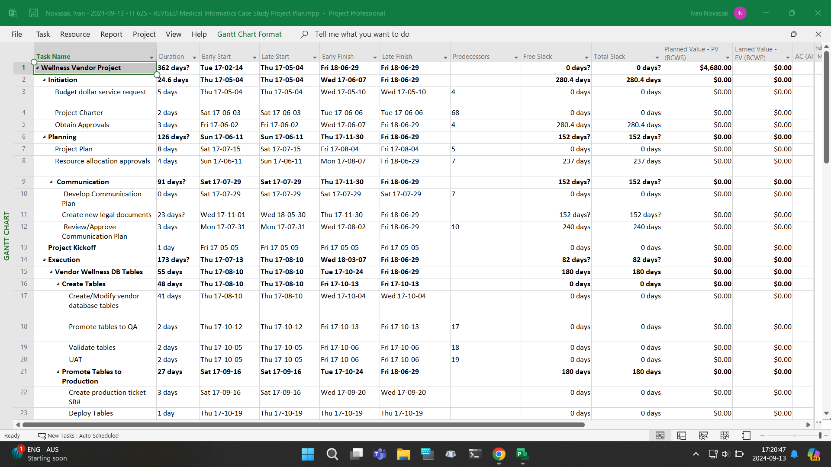

**Figure 8**

*Microsoft Project screenshot showing a listing of tasks #24–47, which comprises the code reviews, wellness vendor reporting, and some of the quality assurance.*

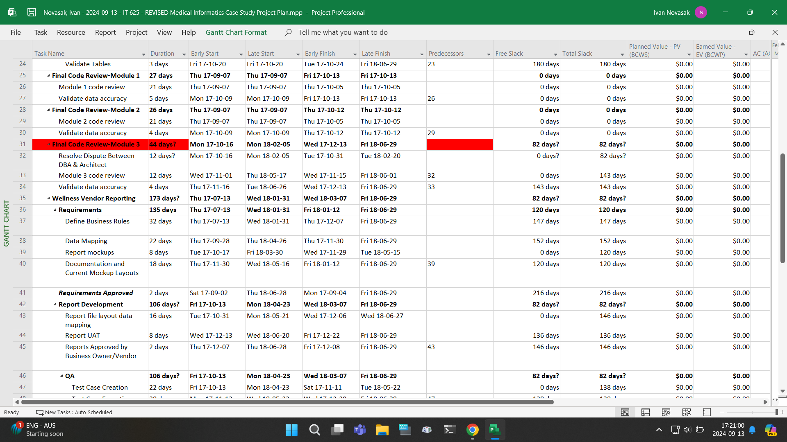

**Figure 9**

*Microsoft Project screenshot showing a listing of tasks #48–68, which comprises most of the monitor and control/support sections, oversight, go live date, and remainder of the wellness vendor reporting sections.*

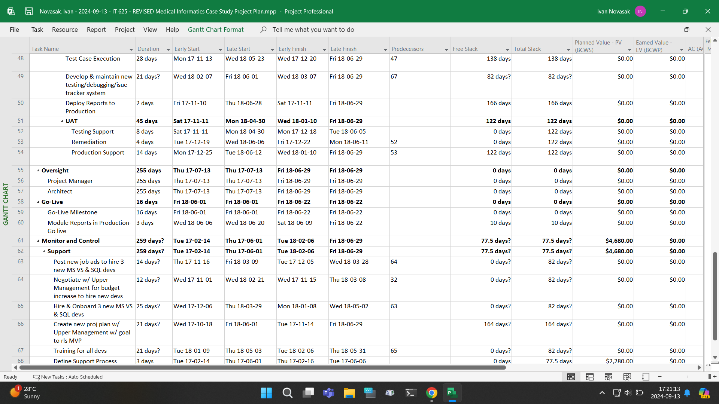

**Figure 10**

*Microsoft Project screenshot showing a listing of tasks #51–72, which has the oversight, go live dates, monitor and control/support, and closing sections.*

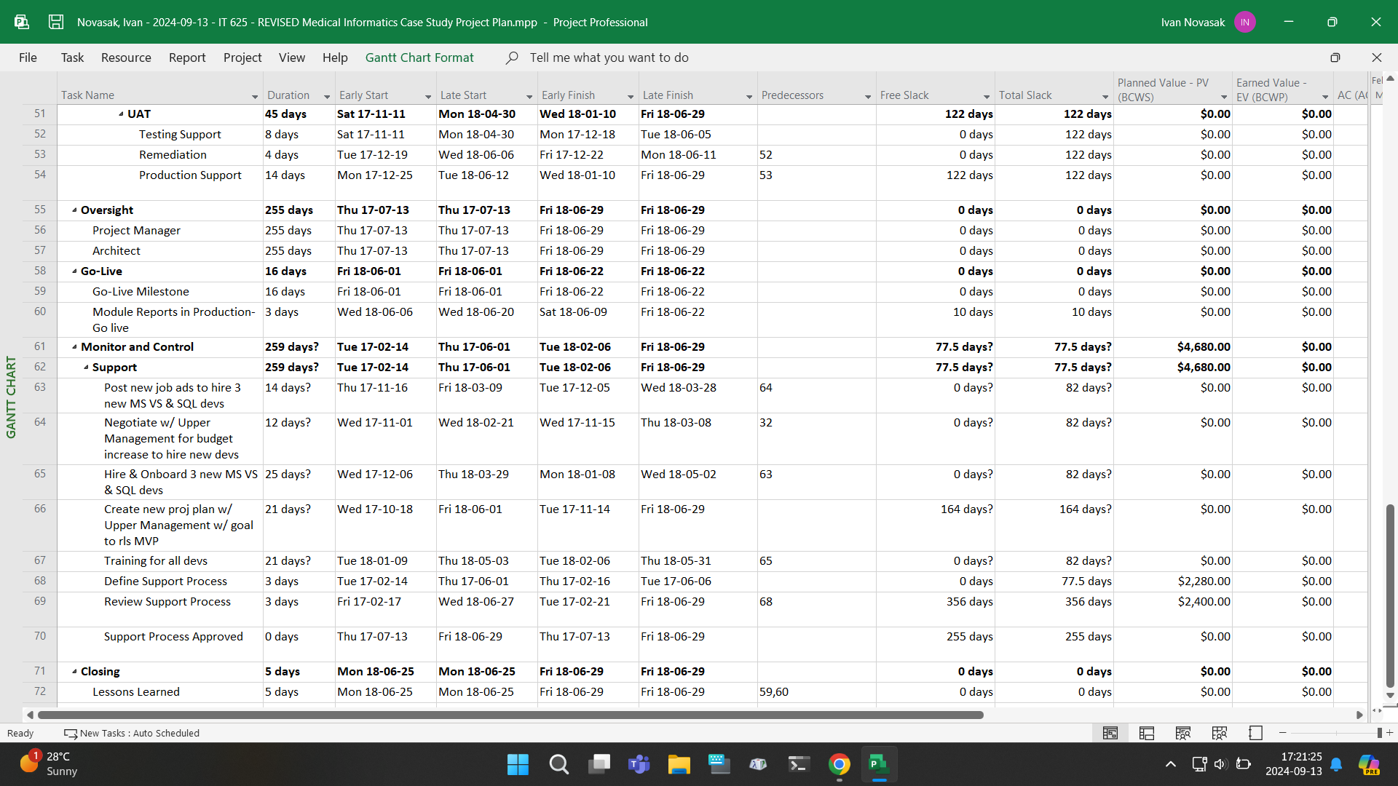

***Tasks That Must be Completed Before Others May Begin***

As shown in Figures 7–10, every task with at least one number listed in the Predecessors cell is a task that can be performed only after the listed predecessor is concluded. The sequences involving the newly added tasks is:

* Seq 1: Resolve DBA1/Architect Dispute → Module 3 code review → Validate data accuracy.
* Seq 2: Resolve DBA1/Architect Dispute → Negotiate with Upper Management for the budget increase to hire new developers → Post new job ads → Hire and onboard 3 new developers → Training developers → Develop and maintain new bug/issue tracking/testing system.

***Tasks That Can be Done Simultaneously***

Some tasks can be done simultaneously without interfering with other tasks. The tasks after Resolve DBA1/Architect Dispute in the two sequences listed above can be done in parallel, with the new employees joining after training is complete. Also, the legal documents creation can be done at the same time the software is being developed or when training is ongoing. Other tasks, such as the Oversight ones, are ongoing and have natural overlap as the project manager’s and architect’s primary roles are the supervision of the project’s progress.

***Duration of Each Task***

The durations of each task and subtask are listed under the Duration column in Figures 7–10. Most of the newly added tasks are between two- and four-weeks’ duration, though the software counts only working days (excludes weekends), so they are listed as shorter durations.

***Planned vs Actual Dates***

It is difficult to ascertain the actual dates from the planned dates, but since according to (Lamont, 2024c, p 1), the project’s issues began in October 2017, which is when John Current left his project manager role at the conclusion of Module 2’s development (Lamont, 2024a, p 3). The dates shown for the newly added tasks in (Novasak, 2024d, pp 7–10) and Figures 1–4 of this document are all planned dates, as it is assumed the project has not yet resumed. The columns displaying Early Start, Early Finish, Late Start, and Late Finish are automatically calculated in Microsoft Project based on the predecessor tasks (Microsoft, n.d.). The actual dates for the project are assumed for all tasks that took place prior to 13 October 2017, the day after Module 2 was finished and John Current left.

**Project Risk Planning**

The next sections involve risks to the project and how to handle them. According to GeeksforGeeks, the five types of risks in software development projects are (GeeksforGeeks, 2024):

* Schedule related, which puts the project behind schedule. This includes improper resource allocation and tracking, frequent scope expansion, and the failure in identification of functions and completing them (GeeksforGeeks, 2024).
* Budget related, which can increase the costs for the company. This can include the wrong estimates for the budget, unexpected scope expansion, mismanagement of handling the budget, improper budget tracking, and cost overruns (GeeksforGeeks, 2024).
* Operational and procedural. These types of risks include having insufficient resources, conflicts between tasks and employees, improper project planning, not enough people who are skilled in the needed areas, lack of communication and cooperation, lack of clarity in who is performing which roles, and insufficient training (GeeksforGeeks, 2024).
* Technical, which affects the functionality and performance of the product. These risks include high complexity in implementation, improper integration of the modules, frequent requirement changes, and not using up-to-date technological frameworks (GeeksforGeeks, 2024).
* Programmatic risks, also known as external or unavoidable risks. These risks include quick market changes, running out of project funds, changes in government laws or policies, and natural disasters (GeeksforGeeks, 2024).

Some other risks GeeksforGeeks list include communication and misunderstanding, security/privacy vulnerabilities, quality risks, legal compliance risks, unexpected costs, and market risks like new competition (GeeksforGeeks, 2024). At Medical Informatics, out of all the risk categories that are listed above, the following have already been identified as happening in (Lamont, 2024a, pp 3–5):

* No resource tracking
* Frequent expansion of the project’s scope
* Unexpected scope expansion
* Conflicts between tasks and employees (notably the database administration / architect conflict)
* Not having enough people who are skilled in Microsoft Visual Studio and SQL
* Lack of communication and cooperation, leading to the DBA/architect conflict
* Insufficient training
* High complexity in implementation, which may originate from not having enough training in MS VS and SQL
* Frequent requirement changes (along with scope creep already mentioned above)
* Not using up-to-date technological frameworks, which may originate from not having enough training in MS VS and SQL.

***The Amount of Uncertainty in the Project and How to Deal with It***

According to the Wrike Team, one method for dealing with uncertainty is called a SWOT analysis, which is where a company’s strengths, weaknesses, opportunities, and threats are identified, with strengths and weaknesses being internal and project-related and the opportunities and threats being external and need to be either capitalised (opportunities) or avoided (threats) (Wrike Team, 2023). For Medical Informatics, the strengths especially reside in the developers’ abilities to communicate well for coding the modules, except the one dispute between the database administration and architect (Lamont, 2024a, pp 4/5). The weaknesses identified involved a lot of communication and planning being delegated to the project manager and relying on prior experiences, rather than documenting the plans and processes (Lamont, 2024a, pp 3–5). Another aspect of development that can be considered a weakness but maybe a strength in a different project is how accommodating the developers were in adapting to the increase in features by continuing to add the new features (Lamont, 2024a, p 4). Possible threats will be covered in the next sections of this document.

***The Threats of Greatest Concern***

According to Kate Eby of Smartsheet, a risk register is a ‘document your project team will use to identify, log, and monitor potential project risks’ (Eby, 2023). It is a table that includes a reference ID, the date it was raised, risk category, risk description (including an if/then statement), probability of occurrence on a scale of 1 to 5, impact on a scale of 1 to 16, risk severity score (which is the probability multiplied by impact), likely timing of the risk, risk triggers, a mitigation and response plan, the status of the mitigation or response, the owner (who is accountable for the risk), and any other useful notes (Eby, 2023). Figures 11–13 show a risk register for Medical Informatics. This risk register is also enclosed with this document as a Microsoft Excel spreadsheet file for easier viewing.

**Figure 11**

*Screenshot of Risk Register table, showing reference ID, the date it was raised, risk category, risk description, probability of occurrence, impact, risk severity score, and likely timing of the risk.*

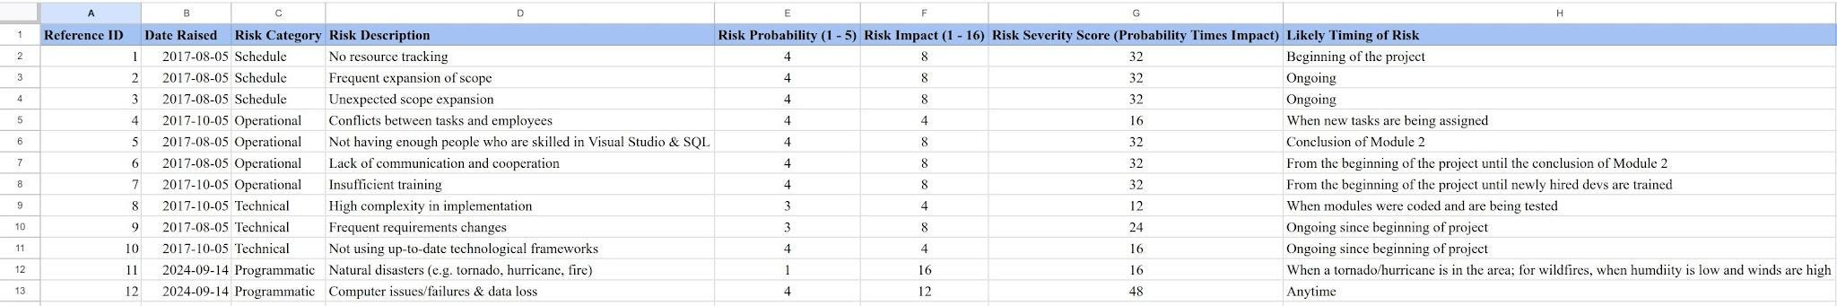

*NOTE*: Adapted from (Eby, 2023).

**Figure 12**

*Screenshot of Risk Register table, showing risk triggers, the mitigation/response plan for each risk, and the status of the mitigation/response.*

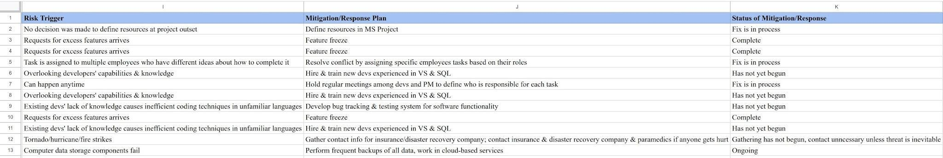

*NOTE*: Adapted from (Eby, 2023).

**Figure 13**

*Screenshot of Risk Register table, showing the status of the mitigation/response, who is accountable, and other notes.*

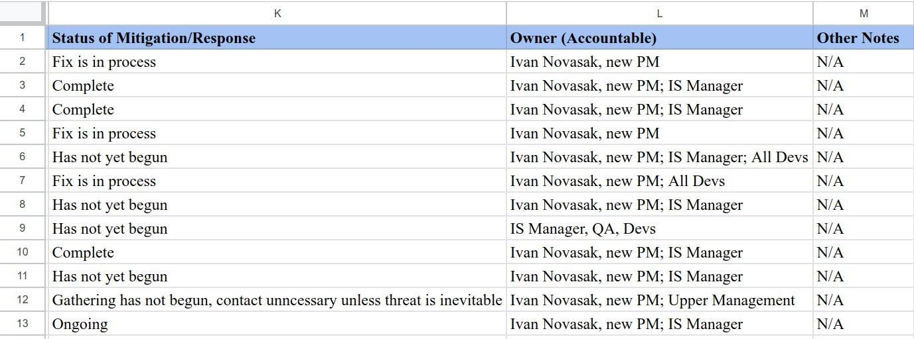

*NOTE*: Adapted from (Eby, 2023).

The threats of greatest concern are the ones with the highest risk severity scores, which are all except the conflict between tasks and employees (16), not using up-to-date frameworks (16), and frequent requirements changes (24). The natural disasters one is an example of a low probability but high-risk event, so the scoring model does not accurately represent the riskiness of this event.

***How Each Threat Should be Dealt With***

According to Sam Barnes of Float, after one identifies the risks, assesses and evaluates the likelihood and impacts of each risk happening, and prioritises which risks require the most attention, the next step is mitigation (Barnes, 2023). Mitigation is when one decides whether to avoid the risk entirely, reduce the likelihood of the risk causing trouble, transfer the risk to a third-party entity, or accept the risk (Barnes, 2023). For the identified risks shown in the Medical Informatics risk register table, only the natural disaster risk is logical to transfer to a third-party entity, given the widespread and non-IT-based required knowledge for handling those types of risks. For the three risks where a feature freeze was the most appropriate strategy, the goal is to avoid the risk of more project delays that may come with accepting repeated customers’ requests for new features. For all other identified risks, the strategies employed are examples of reducing the likelihood of those risks causing problems; they do not eliminate the risks entirely. Full acceptance is not chosen as a strategy for any risk at Medical Informatics.

Another strategy Barnes mentions is to monitor for new risks and ‘facilitate review sessions with owners, ensuring risks are regularly updated’ (Barnes, 2023). Barnes emphasises that the risk register should be taken to be a living document that is open to updating from time to time throughout the project. The final point Barnes notes is that communication is the most important risk management policy and risk statuses should be communicated to the project team and all stakeholders (Barnes, 2023). The types of information that are appropriate to share include ‘likelihood, impact, priority, mitigation, owners, and contingency plans for individual risks’ to make the parties feel at ease that the company has taken all known risks into account (Barnes, 2023).

**Risk Control**

***Appropriate Quantification of the Risks (Probability vs Impact)***

According to Harry Hall of Project Risk Coach, one quantitative risk analysis example is an Expected Monetary Value (EMV) table that can be created that lists out the risks and opportunities, probabilities of them occurring, and the monetary impacts, then multiplies the respective risks by the corresponding probabilities and finally sums the total for the full monetary impact of all risks or opportunities (Hall, 2024). The EMV is defined as the probability multiplied by the monetary impact (Hall, 2024). For Medical Informatics, such a table can be constructed as in Table 7, with the monetary costs of each risk being estimated based off the original budget for the project:

**Table 7**

*Expected Monetary Value (EMV)*

|  |  |  |  |
| --- | --- | --- | --- |
| **Risk** | **Probability** | **Monetary Impact** | **EMV** |
| No resource tracking | 0.8 | -$50,000 | -$40,000 |
| Frequent expansion of scope | 0.8 | -$100,000 | -$80,000 |
| Unexpected scope expansion | 0.8 | -$70,000 | -$56,000 |
| Conflicts between tasks and employees | 0.8 | -$30,000 | -$24,000 |
| Not having enough people who are skilled in Visual Studio & SQL | 0.8 | -$20,000 | -$16,000 |
| Lack of communication and cooperation | 0.8 | -$40,000 | -$32,000 |
| Insufficient training | 0.6 | -$60,000 | -$36,000 |
| High complexity in implementation | 0.6 | -$30,000 | -$18,000 |
| Frequent requirement changes | 0.6 | -$80,000 | -$48,000 |
| Not using up-to-date technological frameworks | 0.8 | -$15,000 | -$12,000 |
| Natural disasters (e.g., tornado, hurricane, fire) | 0.2 | -$250,000 | -$50,000 |
| Computer issues/failures & data loss | 0.8 | -$400,000 | -$320,000 |

The probabilities are expressed as a decimal converted from the 1–5 scale in the risk register table, using the fractions ⅕ for a probability listed as 1, ⅖ for a listing of 2, etc. The monetary impacts are negative because events happening will result in extra costs to Medical Informatics.

***Contingency Funding and Time Buffers in Place to Handle Threats***

According to Debra Patterson who wrote for Pressbooks, contingency plans typically include a contingency fund specifically for unexpected costs that might come up (Patterson, 2022). She lists several examples of items that may require a contingency fund include (Patterson, 2022):

* ‘Inadequate initial estimates’
* ‘Small items not covered in the planning’
* ‘Errors in initial estimates’
* ‘Small deviations due to inevitable delays’.

She also notes that contingency funds are not to cover major deviations from the plan or scope changes (Patterson, 2022). The fund she recommends for a contingency reserve is ‘10% to 15% of the total budget’, though for large, complex projects using ‘more sophisticated modelling of risk for uncertainty’ is also good to use (Patterson, 2022). Using the worst-case scenario budget estimate quoted in (Lamont, 2024a, p 7) of $529,980 along with a 15% contingency fund, the contingency reserve should be at least $79,497.

For contingency time, the plan is to add 4 weeks during March and May as make-up buffers in case there is a snag in the project. The May buffer could extend into the June 2018 launch window, if necessary, as launch is forecast to finish during the final week of June.

**Conclusion**

The plan for reviving Medical Informatics’ Wellness Vendor software project is complete and can be implemented, possibly with further tweaks once it is in motion. Despite the date of this report being 29 September 2024, it is written assuming the project picks up from mid-October 2017, when John Current left his project management post. The data in the screenshots in each figure can be reviewed in the enclosed .mpp and .xls files that accompany this document.

# References

Barnes, S. (2023, March 16). *Here's How to Effectively Manage Risks in Your Next Project*. Float. <https://www.float.com/resources/project-risk-management>

Beattie, A. (2023, January 30). *Understanding first mover advantage*. Investopedia. <https://www.investopedia.com/articles/investing/111016/understanding-first-mover-advantage.asp>

Bigelow, S. J., & Hanna, K. T. (2021, November 15). *TCO (total cost of ownership)*. Data Center. <https://www.techtarget.com/searchdatacenter/definition/TCO>

Brackett. J. (2022, April 20). ‘Nine Effective Tips To Keep A Long-Term Project On Track’. *Forbes*. <https://www.forbes.com/councils/theyec/2022/04/20/nine-effective-tips-to-keep-a-long-term-project-on-track/>

Darby, J. (2024, June 28). *How to build high performance teams*. Thomas International Ltd. <https://www.thomas.co/resources/type/hr-blog/how-build-high-performance-teams>

Davis, K.D. (2024, February 19). *What is Variance in Project Management?* KnowledgeHut Solutions Private Limited. <https://www.knowledgehut.com/blog/project-management/variance-in-project-management>

Eby, K. (2023, February 27). *How to create a project Risk Management Plan*. Smartsheet Inc. <https://www.smartsheet.com/content/project-risk-management-plan>

Fernandes, M. (2023, January 28). *Understanding the Role of Coaching in Project Management.* Mavis Fernandes Associates. <https://mavisfernandes.com/blog/understanding-the-role-of-coaching-in-project-management>

GeeksforGeeks. (2024, June 3). *Different types of risks in Software Project Development*. GeeksforGeeks. <https://www.geeksforgeeks.org/different-types-of-risks-in-software-project-development/>

Glassdoor. (2024). *Salary: Senior Manager in New York City, NY, United States 2024*. Glassdoor LLC. <https://www.glassdoor.ca/Salaries/new-york-city-senior-manager-salary-SRCH_IL.0,13_IM615_KO14,28.htm>

Good, L. (2024a, January 9). *What is a Requirements Traceability Matrix (RTM)?* project-management.com. <https://project-management.com/requirements-traceability-matrix-rtm/>

Good, L. (2024b, April 19). What is a RACI matrix? project-management.com. <https://project-management.com/understanding-responsibility-assignment-matrix-raci-matrix/>

Hall, H. (2024, January 19). *Evaluating risks using quantitative risk analysis*. Project Risk Coach / Harry Hall, LLC. <https://projectriskcoach.com/evaluating-risks-using-quantitative-risk-analysis/>

Herrity, J. (2023, February 28). *10 Ways to Improve Team Cohesiveness in the workplace*. Indeed Career Guide. <https://www.indeed.com/career-advice/career-development/team-cohesiveness>

Jessee, T. (2024, August 27). *30 Project Management KPIs You Should Track in 2024*. ClearPoint Strategy. <https://www.clearpointstrategy.com/blog/important-project-management-kpis>

Lamont, W. (2024a). *IT 625 Final Project Case Study: Medical Informatics*. Southern New Hampshire University. <https://learn.snhu.edu/content/enforced/1678889-IT-625-10164.202457-1/Course%20Documents/IT%20625%20Medical%20Informatics%20Case%20Study%20Full%20Description.pdf>

Lamont, W. (2024b). *IT 625 Milestone One Guidelines and Rubric*. Southern New Hampshire University. <https://learn.snhu.edu/d2l/le/content/1678889/viewContent/34440317/View>

Lamont, W. (2024c). *Medical Informatics Case Study Project Charter PDF*. Southern New Hampshire University. <https://learn.snhu.edu/content/enforced/1678889-IT-625-10164.202457-1/Course%20Documents/IT%20625%20Medical%20Informatics%20Case%20Study%20Project%20Charter.pdf>

Lamont, W. (2024d). *Medical Informatics Case Study Vendor Budget Milestone Status Updates PDF*. Southern New Hampshire University. <https://learn.snhu.edu/d2l/common/dialogs/quickLink/quickLink.d2l?ou=1678889&type=coursefile&fileId=Course+Documents%2fIT+625+Medical+Informatics+Case+Study+Vendor+Budget+Milestone+Status+Updates.pdf>

Landau, P. (2023, June 21). *Cost-Benefit Analysis: A Quick Guide with Examples and Templates*. ProjectManager.com, Inc. <https://www.projectmanager.com/blog/cost-benefit-analysis-for-projects-a-step-by-step-guide>

Larson, E. W., & Gray, C. F. (2020). *Loose leaf for project management: the managerial process*. McGraw-Hill Education.

Microsoft. (n.d.). *Early Finish (task field)*. Microsoft Corporation. <https://support.microsoft.com/en-us/office/early-finish-task-field-95f2c025-cd33-4bdb-b4f4-fd274987c4ef>

Mind Tools Content Team. (2024). *Tuckman’s Model for Nurturing a Team to High Performance*. Mind Tools Ltd. <https://www.mindtools.com/abyj5fi/forming-storming-norming-and-performing>

Novasak, I. (2024a, August 11). *Medical Informatics: Conflict Resolution Plan Draft*. Southern New Hampshire University.

Novasak, I. (2024b, August 18). *Medical Informatics: Project Evaluation Draft*. Southern New Hampshire University.

Novasak, I. (2024c, September 1). *Medical Informatics: Project Charter Draft*. Southern New Hampshire University.

Novasak, I. (2024d, September 8). *Medical Informatics: Scope, Cost, and Quality Planning Report Draft*. Southern New Hampshire University.

Patterson, D. (2022, April 15). *Strategic Project Management (7.11. Contingency funds)*. Pressbooks. <https://ecampusontario.pressbooks.pub/hrstrategicprojectmanagement/chapter/7-11-contingencies/>

PayScale. (n.d.). *Salaries in New York*. PayScale, Inc. <https://www.payscale.com/research/US/State=New_York/Salary>

Pinola, M. (2020, April 10). *The remote worker’s toolkit: The 15 tools you need to work remotely*. Zapier, Inc. <https://zapier.com/blog/productivity-apps-remote-work/>

Røberg, Ø. (2020, May 18). *Why Your Project Baseline is Essential in Project Management*. Safran, JDM Technology Group. <https://www.safran.com/blog/why-baseline-is-essential-in-project-management>

Salles, G. (2023, October 23). *Complete Guide to Quality Key Performance Indicators*. QUALITYWEB 360. <https://www.qualityweb360.com/complete-guide-to-quality-key-performance-indicators/>

Schneider, A. (2023, February 13). *Project sponsor: a look at the role and responsibilities*. monday.com Blog. <https://monday.com/blog/project-management/project-sponsor/>

SurveyMonkey. (n.d.). *SurveyMonkey Enterprise - Turn Insights into Action*. <https://www.surveymonkey.com/product/enterprise/>

Talent.com. (n.d.). *Software Architect salary in New York, NY - Average salary*. Talent.com. <https://www.talent.com/salary?job=Software+Architect&location=New+York%2C+NY>

Tincher, L. (2023, August 3). *Calculating an investment’s payback period*. SoFi. <https://www.sofi.com/learn/content/how-to-calculate-the-payback-period/>

Usmani, F. (2022a, October 10). *Forming, storming, norming, and performing: Tuckman Model*. PM Study Circle. <https://pmstudycircle.com/forming-storming-norming-performing-and-adjourning/>

Usmani, F. (2022b, November 29). *Leadership Styles: Definition, Meaning, & Types of Leadership Styles*. PM Study Circle. <https://pmstudycircle.com/leadership-styles/>

Usmani, F. (2024, June 5). *Five Conflict Resolution Strategies for the Workplace*. PM Study Circle. <https://pmstudycircle.com/best-conflict-resolution-technique/>

Vasiliauskas, V. (2024, June 7). *Earned Value Management: How to calculate it?* Teamhood. <https://teamhood.com/project-management-resources/earned-value-management/>

Walls, P. (2024, September 6). *How Profitable Is A Software Company? (Updated for 2024)*. Starter Story. <https://www.starterstory.com/ideas/software-company/profitability#how-much-does-a-software-company-make-a-week>

Wrike. (n.d.). *What Is a Project Baseline in Project Management?* Wrike, Inc. <https://www.wrike.com/project-management-guide/faq/what-is-a-baseline-in-project-management-project-baseline/>

Wrike Team. (2023, October 6). *Navigating uncertainty: Understanding different types of risks in project management*. Wrike, Inc. <https://www.wrike.com/blog/types-of-risks/>

ZipRecruiter. (2024, September). *Salary: Corporate lawyer in New York City, NY (Sep, 2024)*. ZipRecruiter. <https://www.ziprecruiter.com/Salaries/Corporate-Lawyer-Salary-in-New-York-City,NY>